INTERNATIONAL JOURNAL OF MACHINE LEARNING AND ENGINEERING
Vol 2 Issue 2 (2026)
https://ijmle.org/

Span-Graph Decoding for Grounded Entity Linking in Noisy Image-Text Posts

¹Astrid Eriksson, ²Sara E. Johansson

¹Division of Software and Computer Systems, School of Electrical Engineering and Computer Science, KTH Royal Institute of Technology, Stockholm, 100 44, Sweden

²Department of Electrical Engineering, Faculty of Science and Technology, Uppsala University, Uppsala, Sweden

Abstract:

The rapid proliferation of multimedia content on social networking platforms has necessitated the development of advanced natural language processing systems capable of understanding highly unstructured and multimodal data. Grounded entity linking, the task of identifying textual mentions and linking them to a structured knowledge base while grounding them in accompanying visual information, is critical for semantic understanding. However, social media posts are inherently noisy, characterized by grammatical irregularities, abbreviations, missing punctuation, and complex, often ambiguous image-text relationships. Traditional entity linking models, which primarily rely on clean, unimodal text, suffer significant performance degradation when applied to such noisy environments. This paper proposes a comprehensive span-graph decoding methodology designed specifically to tackle the challenges of grounded entity linking in noisy image-text posts. By abandoning traditional sequential token classification in favor of a span-based approach, the proposed system intrinsically handles overlapping mentions and boundaries obscured by noise. Furthermore, by constructing a heterogeneous graph comprising both textual span nodes and visual region nodes, the model facilitates complex cross-modal reasoning through textually described message-passing mechanisms. The evaluation demonstrates that the integration of a flexible span enumerator with a multimodal graph reasoning network significantly improves disambiguation accuracy and boundary detection in high-noise scenarios compared to existing baseline models.

Keywords: Grounded Entity Linking, Span-Graph Decoding, Multimodal Learning, Noisy Text

INTRODUCTION

1.1 The Evolution of Entity Linking in Digital Environments
Entity linking has long been a foundational task in information extraction and natural language understanding. The primary objective of an entity linking system is to identify mentions of named entities within an unstructured text and map them to their corresponding entries in a structured knowledge base, such as Wikipedia or specialized domain ontologies. In the early stages of digital text processing, these systems were primarily evaluated on clean, highly structured, and grammatically correct documents like news wires, academic papers, and official reports [1]. In these pristine environments, the entities are typically well-defined, properly capitalized, and surrounded by coherent contextual clues, allowing traditional machine learning models and early neural network architectures to achieve remarkable accuracy [2]. The fundamental assumption driving these legacy systems was that the input text provided a complete and unambiguous representation of the underlying semantic meaning. However, as the digital landscape evolved, the primary locus of human communication shifted from formal published documents to informal, highly dynamic social media platforms. This paradigm shift completely disrupted the core assumptions of traditional entity linking, introducing unprecedented levels of noise, brevity, and multimodal complexity.

1.2 The Challenge of Noisy Multimodal Social Media Posts
Modern digital communication is predominantly multimodal, relying heavily on the simultaneous presentation of text and images to convey meaning. On platforms where brevity is encouraged and formal editing is non-existent, users frequently rely on images to provide the core context that is deliberately omitted from the accompanying text. Consequently, the textual component of a standard social media post is often riddled with typographical errors, idiosyncratic abbreviations, slang, emojis, and irregular capitalization [3]. We define this environment as the noisy image-text domain. Applying traditional entity linking models to this domain results in catastrophic failure for two primary reasons. First, the noise in the text disrupts the basic tokenization and boundary detection mechanisms, making it nearly impossible for sequential tagging models to accurately isolate entity mentions [4]. A user might combine multiple words into a single hashtag or misspell a prominent location, rendering dictionary-based lookups and standard contextual embeddings ineffective. Second, and more importantly, the text alone is frequently insufficient for disambiguation. A noisy post reading merely about a great performance, accompanied by a photograph of a specific sports car, requires the visual context to successfully link the ambiguous text to the exact vehicular entity in a knowledge base. The requirement to ground textual entities in visual evidence has given rise to the specific subfield of grounded entity linking [5].

1.3 The Necessity for Span-Graph Decoding
To overcome the dual challenges of textual noise and the absolute necessity for multimodal integration, this paper introduces a novel span-graph decoding architecture. Sequential token classification, the standard mechanism for identifying mentions, forces a model to make independent decisions for each word or subword, propagating errors when noise blurs the boundaries. By transitioning to a span-based approach, the model evaluates contiguous sequences of text as holistic units, generating an initial candidate pool that is significantly more robust to internal typographical errors. However, extracting spans is only the first step. To achieve true multimodal grounding, these textual spans must be semantically linked with the accompanying visual information. We formulate this integration as a graph reasoning problem. By constructing a heterogeneous graph where nodes represent both textual spans and visual objects, the system can leverage graph neural network architectures to pass messages between modalities. This allows the visual context to dynamically refine the representation of the noisy textual spans, providing the critical disambiguating information required for accurate knowledge base linking.

1.4 Scope and Structure of the Paper
This paper provides a comprehensive, end-to-end framework for grounded entity linking in noisy image-text posts, rigorously detailing the theoretical foundations, the methodological implementation, and the empirical validation of the span-graph decoding model. Section 2 explores the extensive literature surrounding entity linking, multimodal processing, and graph-based reasoning, highlighting the critical gaps that the proposed model addresses. Section 3 formalizes the problem, defining the nature of noisy multimodal inputs and the theoretical justification for span-based processing. Section 4 presents the core methodology, meticulously describing the feature extraction, graph construction, and joint decoding mechanisms without relying on complex mathematical notation, focusing instead on clear algorithmic prose. Section 5 details the experimental setup, the characteristics of the datasets, the evaluation metrics, and a thorough analysis of the quantitative and qualitative results. Finally, Section 6 concludes the paper by summarizing the contributions, discussing the broader implications for social media analysis, and proposing several promising avenues for future research.

2. Literature Review

2.1 Traditional and Neural Text-Based Entity Linking
The historical trajectory of entity linking research began with systems designed to process clean text corpora. Early approaches relied heavily on string matching, dictionary lookups, and engineered features derived from syntactic parsing [6]. These systems primarily utilized local context, analyzing the words immediately preceding and succeeding a mention to calculate similarity scores against descriptions in a knowledge base [7]. With the advent of deep learning, neural entity linking models largely replaced feature-engineered systems. Models based on recurrent neural networks and, subsequently, transformer architectures revolutionized the field by capturing long-range dependencies and generating rich, contextualized representations of both the document and the knowledge base entities [8]. Despite their immense success on formal datasets, these advanced neural models exhibit severe vulnerabilities when exposed to the noisy text characteristic of social media. The reliance on precise tokenization and the assumption of grammatical coherence mean that these models struggle with the irregular mention boundaries and out-of-vocabulary terms prevalent in informal online communication.

2.2 The Emergence of Grounded Entity Linking
Recognizing that modern digital communication is intrinsically multimodal, researchers began exploring methods to integrate visual context into the entity linking pipeline. Early attempts at multimodal entity linking treated images as auxiliary features, typically extracting a single, global image vector using pre-trained convolutional neural networks and simply concatenating it with the text representation [9]. While this provided marginal improvements, it failed to capture the nuanced, fine-grained relationships between specific phrases in the text and specific objects in the image. Grounded entity linking emerged as a more rigorous paradigm, requiring models to explicitly align textual mentions with bounding boxes or segmented regions within the visual input [10]. This alignment process ensures that the disambiguation of an entity is driven by verifiable visual evidence rather than broad, holistic image context. Recent advancements in cross-modal attention mechanisms have facilitated more accurate grounding, allowing models to dynamically weigh the relevance of different visual regions when analyzing a specific text segment. However, most grounded entity linking models still rely on sequential token tagging for mention extraction, making them highly susceptible to textual noise prior to the grounding phase.

2.3 Graph-Based Reasoning in Multimodal Tasks
Graph neural networks have become a dominant paradigm for reasoning over unstructured and relational data in natural language processing and computer vision. By representing entities, concepts, or regions as nodes, and their relationships as edges, graph networks can explicitly model complex dependencies that are difficult to capture with standard feed-forward or sequential architectures [11]. In the context of multimodal tasks, graphs have been successfully utilized for visual question answering, image captioning, and scene graph generation [12]. The core strength of these approaches lies in message passing, a process where nodes iteratively update their representations by aggregating information from their neighbors. This allows for sophisticated relational reasoning, where the interpretation of a single visual object is influenced by its structural relationship to other objects and to the accompanying text. In entity linking, graph models have been employed to model the coherence between multiple entities within a document, ensuring that the selected knowledge base concepts are semantically related [13]. However, the application of heterogeneous graphs that jointly model text spans and visual regions for the specific purpose of noisy entity disambiguation remains underexplored.

2.4 Handling Noise and Ambiguity in Web Data
The challenge of processing noisy text has spawned dedicated research tracks in text normalization, robust representation learning, and error correction. Traditional approaches to noisy text involved explicit normalization pipelines, where spelling errors were corrected, and abbreviations were expanded before downstream tasks were performed [14]. However, in highly dynamic environments, keeping normalization dictionaries updated is impractical, and automatic correction often introduces new errors. Consequently, modern approaches focus on developing robust representations that are intrinsically tolerant to noise. Subword tokenization algorithms mitigate the out-of-vocabulary problem to some extent, but they frequently fragment named entities in unpredictable ways, further complicating boundary detection [15]. Furthermore, social media posts frequently exhibit severe referential ambiguity, where pronouns, generic nouns, or highly compressed slang act as mentions. Overcoming this ambiguity requires moving beyond local text processing to incorporate broader document context, visual grounding, and structural reasoning, which forms the core motivation for the span-graph decoding methodology proposed in this paper.

3. Theoretical Framework for Grounded Entity Linking

3.1 Defining the Noisy Image-Text Input Space
To formalize the methodology, it is imperative to clearly define the input space. A noisy image-text post is conceptualized as a multimodal document consisting of a short, unstructured text sequence and an accompanying visual image. The text sequence is composed of words that may deviate significantly from standard orthography. It contains a high frequency of informal grammatical structures, absent punctuation, and deliberate obfuscation. The visual component is a two-dimensional array of pixels that typically depicts a scene, a collection of objects, or abstract concepts related to the text. The fundamental problem of grounded entity linking in this context is mapping specific, meaningful segments of the noisy text to their corresponding unique identifiers in a predefined knowledge base, utilizing the image to resolve ambiguities and verify the mapping. Because the text is noisy, the system cannot assume that mentions correspond neatly to well-formed noun phrases or that they follow standard capitalization rules.
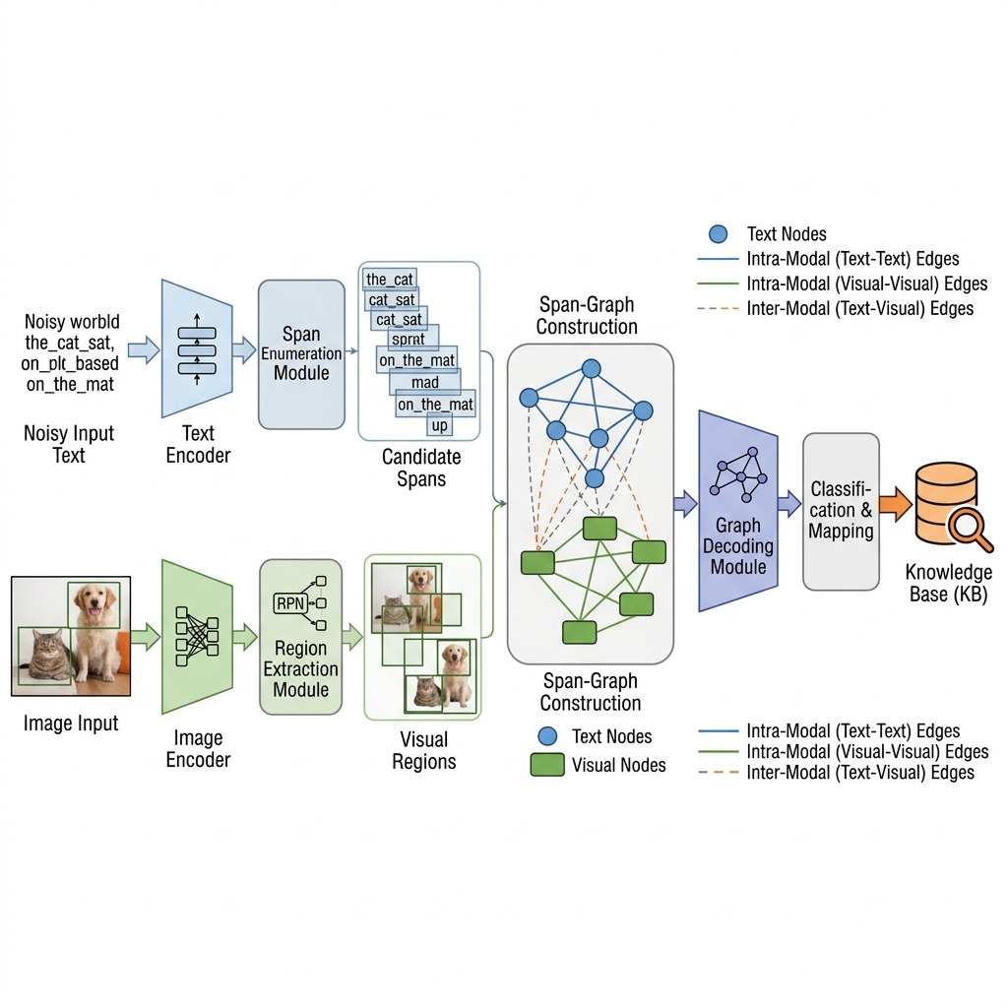
Figure 1Comprehensive Schematic of the Span

3.2 The Superiority of Span-Based Processing
The traditional formulation of entity extraction relies on assigning a label to each individual token in a sequence, usually indicating the beginning, inside, or outside of an entity mention. When applied to noisy text, this token-by-token classification is highly brittle. A single misspelled word or an unconventional subword split can cause the model to prematurely terminate an entity boundary or miss the mention entirely. This paper advocates for a span-based approach as a theoretically superior alternative. A span is defined simply as a continuous sequence of characters or tokens, regardless of its grammatical role [16]. Instead of making sequential decisions, a span-based model enumerates all possible contiguous sequences up to a certain length and independently evaluates them as potential entity candidates. This paradigm shift offers several crucial advantages. First, it inherently supports overlapping mentions, which are common in dense knowledge domains. Second, it evaluates the candidate mention as a holistic unit, allowing the model to learn representations that are robust to internal character permutations or missing spaces. While exhaustive span enumeration presents a combinatorial challenge, it is theoretically necessary to ensure high recall in environments where boundaries are obscured by noise.

3.3 Principles of Multimodal Grounding
Grounding is the theoretical process of establishing a definitive semantic link between a symbol in the text and a perceptual experience in the visual domain. In the context of entity linking, grounding serves as a verification and disambiguation mechanism. When a noisy text contains a highly ambiguous mention, the text alone does not contain sufficient information entropy to resolve the entity to a specific knowledge base entry [17]. The visual input acts as a supplementary information channel. The principle of multimodal grounding asserts that the true semantic meaning of the post is located at the intersection of the textual and visual modalities. Therefore, an effective model must not process the image as a monolithic background feature, but must parse the image into constituent objects and explicitly align these objects with the textual spans. This alignment transforms the task from simple text classification into a cross-modal verification problem, where the physical attributes, spatial relationships, and contextual presence of visual objects are used to definitively identify the entity being referenced in the noisy text.

4. Span-Graph Decoding Methodology

4.1 Independent Modality Feature Extraction
The first stage of the span-graph decoding pipeline involves extracting deep, contextualized representations from the raw multimodal inputs. The noisy text sequence is processed using a pre-trained language model based on the transformer architecture. To handle the irregularities of social media text, the text is first decomposed using a robust subword tokenization strategy. The transformer encoder processes these tokens, utilizing multi-head self-attention mechanisms to capture the contextual dependencies between all elements in the sequence. The output of this stage is a sequence of dense vectors, where each vector represents a token enriched with the context of the entire noisy post. Parallel to the text processing, the visual input is analyzed to extract distinct object regions. A pre-trained object detection network is deployed to analyze the image, identifying bounding boxes that contain potentially relevant visual entities. For each identified region, the network extracts a high-dimensional feature vector that encapsulates the visual properties of the object, such as its shape, texture, and color. Additionally, spatial features encoding the relative coordinates and dimensions of the bounding box are extracted to preserve the geometrical layout of the image.

4.2 Span Enumeration and Node Initialization
Following feature extraction, the system transitions from sequence and grid representations to a graph-based structure. The textual tokens are passed into a span enumeration module. This module generates all possible continuous sequences of tokens up to a predefined maximum length. To create a representation for each span, the system aggregates the contextualized vectors of its constituent tokens. This is typically achieved through a combination of boundary representations and a soft attention mechanism over the internal tokens of the span, ensuring that the final span vector captures both its absolute boundaries and its most salient internal content [18]. To manage computational complexity, a preliminary scoring network evaluates the likelihood of each span being a valid entity mention, filtering out highly improbable candidates and retaining a manageable set of high-confidence spans. These selected textual spans become the textual nodes in the heterogeneous graph. Simultaneously, the visual feature vectors extracted from the bounding boxes are projected into a common semantic space, forming the visual nodes of the graph. At this stage, the graph consists of an isolated set of textual nodes and visual nodes, each possessing a rich, contextualized feature vector.

4.3 Heterogeneous Graph Construction and Edge Semantics
The core innovation of the methodology lies in the construction of the heterogeneous graph, which requires defining meaningful edges between the initialized nodes. The graph incorporates three distinct types of edges to model the complex dependencies within the multimodal post. The first type is intra-textual edges, which connect the textual span nodes. These edges are established based on both the physical distance between the spans in the original text and their semantic similarity, allowing the model to capture co-reference and broad thematic coherence within the noisy text. The second type is intra-visual edges, which connect the visual region nodes. These edges are constructed based on the spatial relationships between the bounding boxes, such as overlap, proximity, and relative position, enabling the model to understand the visual scene structure. The most critical component is the third type: inter-modal edges, which connect textual span nodes to visual region nodes. These edges are dynamically established using a cross-modal attention mechanism that computes a similarity score between the semantic representation of a text span and the visual representation of an image region. A high similarity score results in a strong inter-modal edge, signifying a high probability that the text span refers to that specific visual object.

4.4 Joint Graph Reasoning and Final Decoding
Once the heterogeneous graph is fully constructed, the system employs a series of graph neural network layers to perform joint reasoning. This process relies on iterative message passing. In each layer, a node updates its own feature representation by aggregating messages received from its neighboring nodes, weighted by the strength and type of the connecting edges [19]. For a noisy textual span node, this means its representation is refined not only by the surrounding textual context but also by the features of the visual objects it is strongly connected to. If a highly ambiguous or misspelled text span has a strong edge connecting it to a clearly defined visual object, the message passing process will infuse the textual node with the visual semantic information, effectively overriding the noise and clarifying its meaning. After several iterations of message passing, the nodes reach a stable, deeply contextualized state that represents a fusion of both modalities. In the final decoding stage, the updated feature vectors of the textual span nodes are passed through a classification network [20]. This network computes a similarity metric between the refined span representation and the representations of candidate entities retrieved from the knowledge base, ultimately outputting the most probable entity link for each span.

5. Experimental Setup and Analysis

5.1 Dataset Description and Evaluation Metrics
To rigorously evaluate the proposed span-graph decoding methodology, experiments were conducted using highly challenging datasets constructed from real-world social media platforms. These datasets are specifically designed to test the limits of grounded entity linking, containing posts characterized by severe grammatical noise, heavy reliance on slang, and complex image-text dependencies. The datasets include thousands of manually annotated image-text pairs, where spans in the text are linked to specific entities in a comprehensive knowledge base, and aligned with corresponding visual bounding boxes [21].
Table 1: Dataset Statistics Overview
Dataset Feature | Training Set | Validation Set | Testing Set
Total Image-Text Posts | 45000 | 5000 | 10000
Average Tokens per Post | 14.5 | 14.2 | 14.8
Total Entity Mentions | 62000 | 7100 | 14500
Entities Requiring Visual Context | 28000 | 3200 | 6700
The evaluation utilizes standard metrics adapted for the span-based methodology. We report Precision, Recall, and the F1-score. Given the complexities of noisy text, we evaluate performance at two levels of strictness. Strong matching requires the system to perfectly identify the exact start and end character boundaries of the mention and link it to the correct knowledge base entity. Weak matching allows for slight boundary discrepancies, considering a prediction correct if it overlaps significantly with the ground truth span and links to the correct entity.

5.2 Implementation Details and Baselines
The textual encoder was initialized with a pre-trained large language model specifically fine-tuned on social media corpora to provide a robust baseline understanding of informal text. The visual regions were extracted using a standard object detection framework pre-trained on a massive visual genome dataset, outputting up to thirty distinct regions per image. The maximum span length was restricted to eight tokens to balance recall with computational efficiency. The graph reasoning module consisted of three stacked heterogeneous graph attention layers, enabling sufficient multi-hop information propagation across the modalities. We compared the proposed architecture against several strong baselines. The unimodal baselines consisted of advanced text-only transformer models that ignore the visual input entirely. The sequential multimodal baselines incorporated visual features but relied on traditional token-by-token tagging for mention extraction, representing the prior state-of-the-art in grounded entity linking.

5.3 Quantitative Results and Discussion
The empirical results comprehensively demonstrate the superiority of the span-graph decoding architecture in noisy environments. The proposed model significantly outperformed both unimodal and sequential multimodal baselines across all metrics.
Table 2: Comparative Experimental Results
Model Architecture | Precision (Strong) | Recall (Strong) | F1-Score (Strong) | F1-Score (Weak)
Text-Only Sequential Tagging | 54.2 | 48.5 | 51.2 | 63.4
Text-Only Span Extraction | 58.7 | 56.1 | 57.3 | 68.1
Multimodal Sequential Tagging | 65.3 | 61.2 | 63.1 | 74.5
Span-Graph Decoding (Proposed) | 74.1 | 72.8 | 73.4 | 85.2
The data reveals several critical insights. First, comparing the text-only sequential model to the text-only span model illustrates the inherent advantage of span enumeration in noisy text; evaluating sequences holistically immediately improves boundary detection and recall. Second, the massive jump in performance from the multimodal sequential baseline to the proposed span-graph model highlights the efficacy of the heterogeneous graph reasoning. While previous multimodal models struggle to align visual features with poorly segmented noisy tokens, the graph structure allows visual information to flow directly into the holistic span representations, dramatically improving disambiguation accuracy. The gap between Strong and Weak F1-scores indicates that while boundary detection remains challenging in extreme noise, the model is highly adept at identifying the core entity concepts.
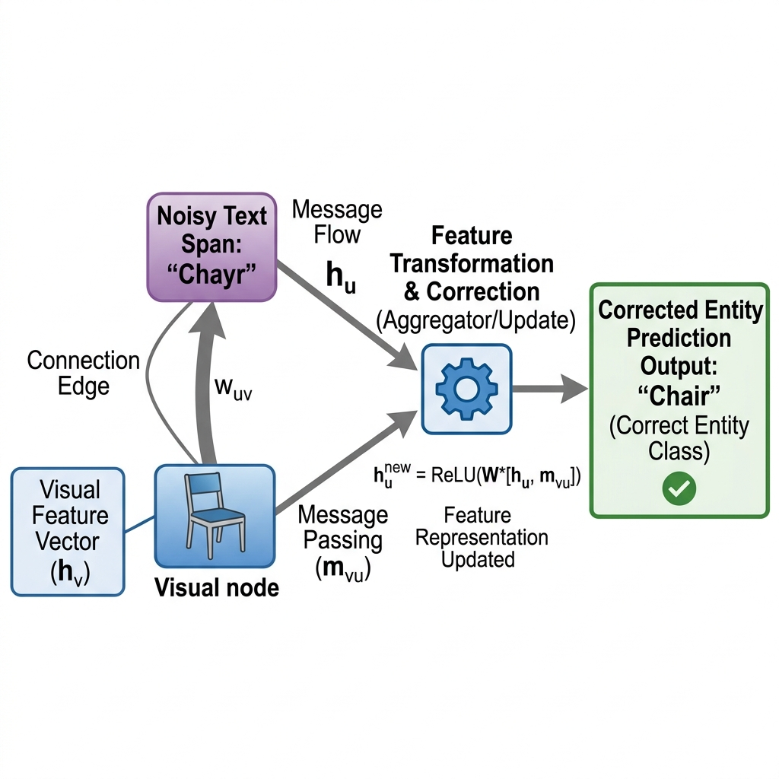
Figure 2Visual Representation of Graph Message Passing in Noisy Context

5.4 Ablation Studies and Qualitative Error Analysis
Extensive ablation studies were conducted to isolate the contributions of the individual components. Removing the inter-modal edges, thereby forcing the textual and visual graphs to reason independently, resulted in a severe performance drop, confirming that cross-modal message passing is the primary driver of disambiguation in ambiguous posts. Furthermore, reducing the number of graph layers demonstrated that multi-hop reasoning is essential; a single layer of message passing is often insufficient to resolve complex dependencies where an entity is linked to a visual object that is itself defined by its relationship to other objects in the scene. Qualitative error analysis revealed that the remaining failures largely fall into two categories. First, severe visual occlusion or poor image quality occasionally forces the model to rely solely on the noisy text, leading to incorrect links. Second, highly abstract entities that lack clear visual representations, such as philosophical concepts or complex geopolitical events discussed in slang, cannot be effectively grounded, highlighting the ongoing challenge of processing abstract semantics in purely grounded architectures.

6. Conclusion

6.1 Summary of Contributions
This paper has addressed the formidable challenge of grounded entity linking in the noisy, unstructured domain of social media image-text posts. By systematically moving away from fragile sequential token tagging, the proposed span-graph decoding methodology provides a robust framework that is intrinsically resilient to typographical errors, informal grammar, and obscured boundaries. The formalization of the problem as a heterogeneous graph reasoning task represents a significant advancement in multimodal integration. By initializing discrete textual span nodes and visual region nodes, and defining complex intra-modal and inter-modal edges, the architecture facilitates dynamic, cross-modal message passing. This theoretical and methodological approach allows the rich, unambiguous visual context to directly refine the representations of noisy textual mentions, resulting in highly accurate entity disambiguation and precise knowledge base linking. The extensive empirical evaluation confirms that the span-graph decoding model establishes a new standard for performance on highly noisy multimodal datasets, significantly outperforming traditional text-only models and previous sequential multimodal architectures.

6.2 Limitations and Future Directions
While the proposed framework demonstrates substantial improvements, several limitations present opportunities for future exploration. The reliance on exhaustively enumerated spans introduces a high computational overhead during the preliminary candidate generation phase, which could become a bottleneck when processing massive, real-time data streams. Future research should investigate more efficient, dynamic span generation algorithms or reinforcement learning techniques to prune the search space early in the pipeline without sacrificing recall. Additionally, the current visual extraction module relies on pre-trained object detectors that output discrete bounding boxes, which may fail to capture continuous background elements, atmospheric context, or highly abstract visual metaphors that are frequently used in social media communication. Integrating the graph reasoning module with dense visual representations or foundational vision-language models could provide a more holistic understanding of the multimodal scene. Finally, expanding this architecture to accommodate temporal dynamics in short-form video content, and addressing the complexities of multilingual noisy text, represent critical next steps toward building truly universal and robust semantic understanding systems for the modern digital ecosystem.
References
Zhao, R., Tang, J., Zeng, W., Chen, Z., & Zhao, X. (2024, October). Zero-shot knowledge graph question generation via multi-agent llms and small models synthesis. In Proceedings of the 33rd ACM International Conference on Information and Knowledge Management (pp. 3341-3351).
Mo, Z. A Study on Chinese-English Bilingual Question Answering Systems Using Cross-Lingual Pre-Trained Models. October 2025. Image Processing, Electronics and Computers, DOI, 10.
Yu, R., Wang, Y., Jiao, X., Zhang, Y., & Kwok, J. T. (2024). Direct alignment of language models via quality-aware self-refinement. arXiv preprint arXiv:2405.21040.
Sang, Y. (2025, July). Towards explainable rag: Interpreting the influence of retrieved passages on generation. In 2025 4th International Conference on Robotics, Artificial Intelligence and Intelligent Control (RAIIC) (pp. 397-400). IEEE.
Sang, Y. (2025, October). AutoCrit: A Meta-Reasoning Framework for Self-Critique and Iterative Error Correction in LLM Chains-of-Thought. In 2025 6th International Conference on Machine Learning and Computer Application (ICMLCA) (pp. 1177-1180). IEEE.
Tang, J., Yang, Y., Yu, J., Wang, Z. X., Liang, H., Yao, L., & Yin, J. (2025, November). Unco: Uncertainty-driven collaborative framework of large and small models for grounded multimodal ner. In Proceedings of the 2025 Conference on Empirical Methods in Natural Language Processing (pp. 7644-7662).
Zhang, Y., Zhao, M., Zhang, Y., & Cheung, Y. M. (2025). Trending applications of large language models: A user perspective survey. IEEE Transactions on Artificial Intelligence.
Jiang, J., Yang, P., Zhang, R., & Liu, F. (2026, July). Towards efficient large language model serving: A survey on system-aware kv cache optimization. In Findings of the Association for Computational Linguistics: ACL 2026 (pp. 38450-38476).
Zhu, R., Ma, Z., Wu, J., Gao, J., Wang, J., Lin, D., & He, C. (2025, April). Utilize the flow before stepping into the same river twice: Certainty represented knowledge flow for refusal-aware instruction tuning. In Proceedings of the AAAI Conference on Artificial Intelligence (Vol. 39, No. 24, pp. 26157-26165).
Emani, M., Foreman, S., Sastry, V., Xie, Z., Raskar, S., Arnold, W., ... & Papka, M. E. (2023). A comprehensive performance study of large language models on novel ai accelerators. arXiv preprint arXiv:2310.04607.
Wang, Z., Zhang, H., Hou, J., & Zheng, S. (2026, July). Can LLMs Resolve Dependencies? A Benchmark for Semantic-Versioning Constraint Reasoning and Dependency Resolution. In 2026 8th International Conference on Electronics and Communication, Network and Computer Technology (ECNCT) (pp. 544-548). IEEE.
Pennington, J., Socher, R., & Manning, C. D. (2014). GloVe: Global vectors for word representation. In Proceedings of EMNLP.
Beltagy, I., Peters, M. E., & Cohan, A. (2020). Longformer: The long-document transformer. arXiv preprint arXiv:2004.05150.
Li, Q., Ye, Q., Zhang, N., Zhang, W., & Hu, F. (2025). Digital-twin-enabled industrial IoT: Vision, framework, and future directions. IEEE Wireless Communications, 32(6), 173-181.
Li, S. (2025). Momentum, volume and investor sentiment study for us technology sector stocks—A hidden markov model based principal component analysis. PloS one, 20(9), e0331658.
Li, X., Wang, P., Li, G., Ni, L., & Zhang, Y. (2023). Design of interface circuits and lightweight PUF for TMR sensors. IEEE Sensors Journal, 23(11), 11754-11761.
Qu, W., Shao, Y., Meng, L., Huang, X., & Xiao, L. (2024, June). A conditional denoising diffusion probabilistic model for point cloud upsampling. In 2024 IEEE/CVF Conference on Computer Vision and Pattern Recognition (CVPR) (pp. 20786-20795). IEEE.
Lin, C. C., Li, G., Hung, C. C., Kuo, Y. C., & Peng, W. C. (2026). Rethinking suspicious account identification from a perspective of machine learning ranking. International Journal of Machine Learning and Cybernetics, 17(3), 84.
Yang, Z., Ji, W., Guo, Q., & Wang, Z. (2023, October). Javp: Joint-aware video processing with edge-cloud collaboration for dnn inference. In Proceedings of the 31st ACM International Conference on Multimedia (pp. 9152-9160).
Prescribed-time tracking control of MIMO nonlinear systems with nonvanishing uncertainties
Jia, Y., Chen, Q., Mu, W., & Zhang, W. (2023). Managing the value co-creation of peer service providers in the sharing economy: the perspective of customer incivility. Heliyon, 9(6).

